**Request Account Masquerading:**

This is a brief guide on how to request and attain Zerto account masquerading capabilities for Analytics. The request will grant access to the number of selected accounts for 24 hours.

Please follow the steps below:

1. Through Okta, log into ServiceNow and select the “Submit a request” button block.
2. Within the service catalog view, select the “Business Applications” option on the left-hand side of the page:
3. Select the “Masquerading Management” button block located on the Business Applications page:

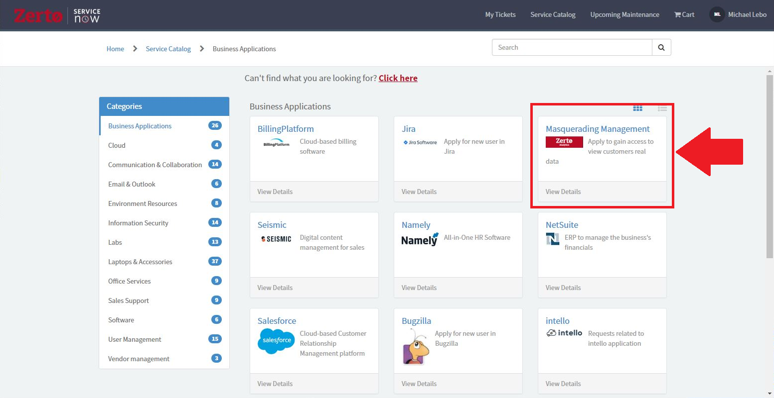

1. Fill in the required fields and submit the request form:
   * Required Permissions: The number of accounts you would like to view
   * Business Justification: Brief description of the use case for the request.

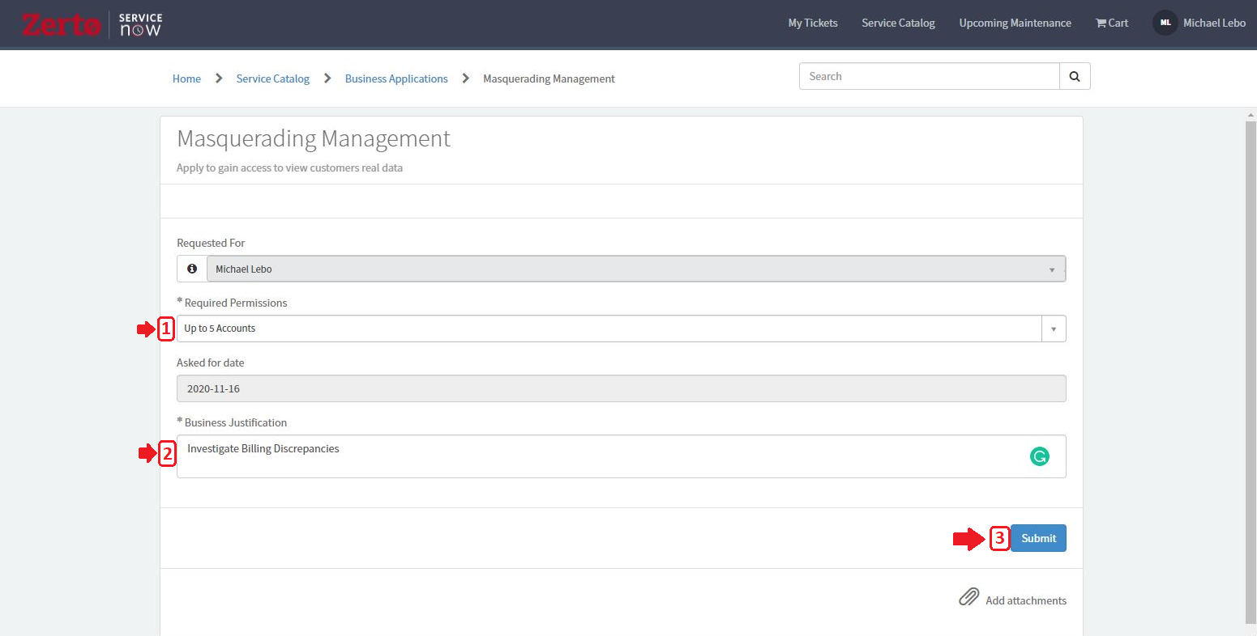

Once submitted, you should receive an approval email within the next few minutes. Requests are automatically approved without manager intervention. You can then view the account Analytics through the Salesforce account page.

Note: You may need to log out of Analytics and back in for masquerading to take effect.

Additionally:

* Access per request is limited to 24 hours
* User cannot create a ticket for future dates.
* User can open one extension request per day.